DATA.ML.300 Computer Vision
Exercise Round 2
Answered to questions 1-2
1)
a)
Hidden unit output:
Output unit output:
b)
c)
Numerical value:
d)

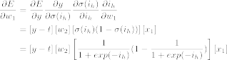
Numerical value:

2.
a)
b)
By euclidean distance, the vector is closer to (smaller distance). By cosine similarity, the vector is closer to (cosine of the angle is closer to 1 angle between vectors is closer to 0 vectors are more parallel).

